Bluetooth connection using a Belkin Bluetooth Adapter to iRobot Create
- Power up the Create. The power indicator should be green and the Create should sound a beep upon startup. Note the Bluetooth address on the front side of the BAM.

- Open up My Bluetooth Places by double clicking the icon.

- Insert the Bluetooth dongle. Computer should sound a beep to signal it has recognized the device.

- Open up click on “View devices in range.” The program will do a search for Bluetooth devices. An Element Serial object should display. Right click and select properties. Make sure the address matches your Create’s address.

- Right click and select “Connect to Bluetooth Serial Port.” The Element Serial should have two green arrows in its bottom left corner indicating a successful connection. Note the Com Port number that you are given.

Follow these steps to install the correct driver for the Bluetooth device:
  - Right click your Bluetooth device (not Microsoft enumerator) and select update driver
  - Select the option, “Install from a list or specific location.” Click next
  - Select the option, “Don’t search. I will choose the driver to install.” Click next
  - Click on “Have Disk.” Browse to “C:\Program Files\belkin\Bluetooth Software\bin” and click OK. Click next
  - A warning message will appear. Click on “Continue Anyway.”
  - The driver will install. Select finish when prompted and your device should now show under Universal Serial Bus controllers
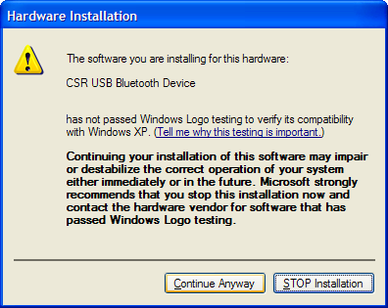
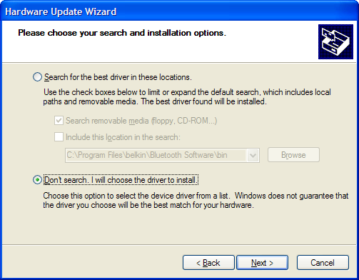
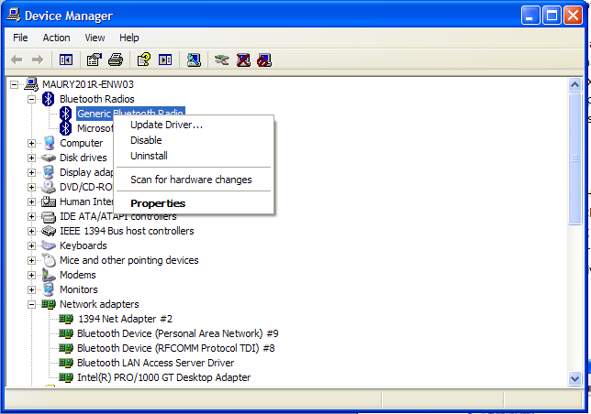
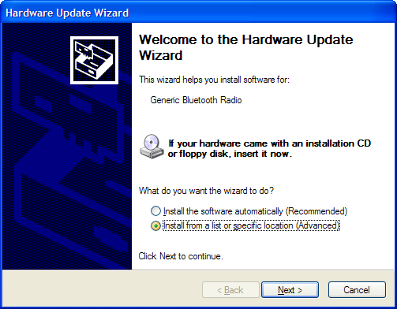
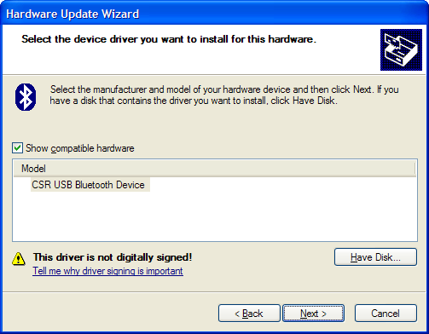
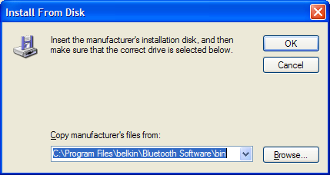

If you get a script error when you start My Bluetooth Places. Click yes/Ok/Ignore on any error messages that pop up. Then, in the upper left corner of the application window, right click: enable ActiveX. Close My Bluetooth Places. Open again. Proceed.
If the search quickly terminates and reports no devices found, the computer may be using the incorrect driver for the Belkin adapter. To check Open up device manager: Right click on My Computer and go to properties. Click on hardware and select Device Manager. Scroll down and expand Universal Serial Bus controllers. The Bluetooth dongle should appear. If it does not show up under Universal Serial Bus controllers but instead under Bluetooth radios, the correct drivers need to be installed.

